* I used google colab as spark is slowing my laptop and I need to restart several times. I am providing the screen shots and the .ipynb file which I used in google colab.
* Installed pyspark and findspark.
* 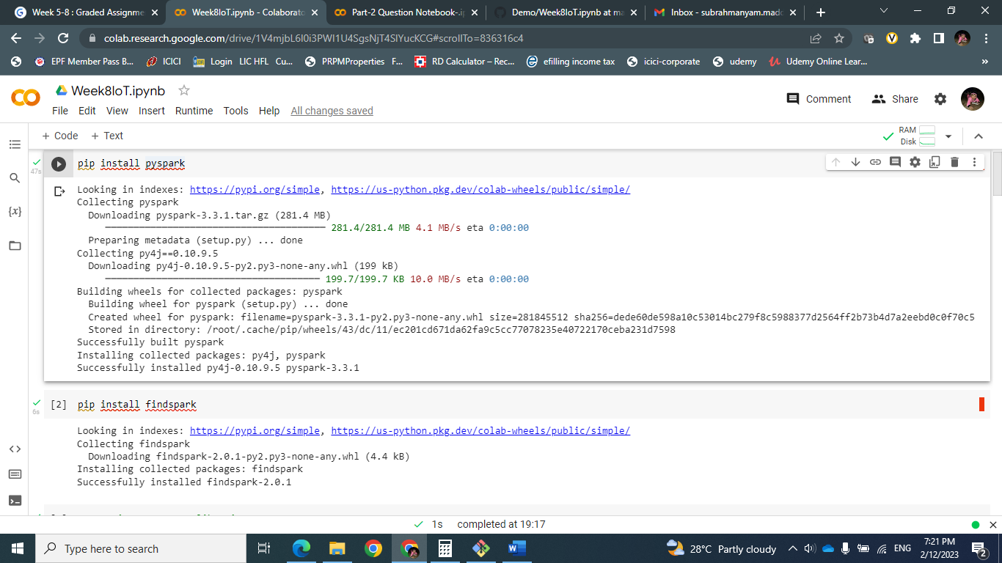
* Imported necessary libraries and created spark session.
* 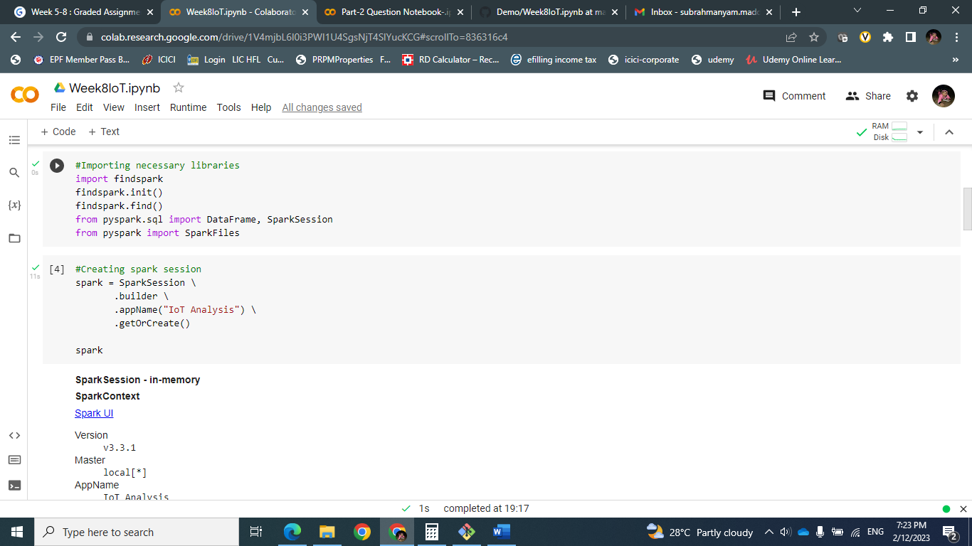
* Loaded json file and created view iot
* 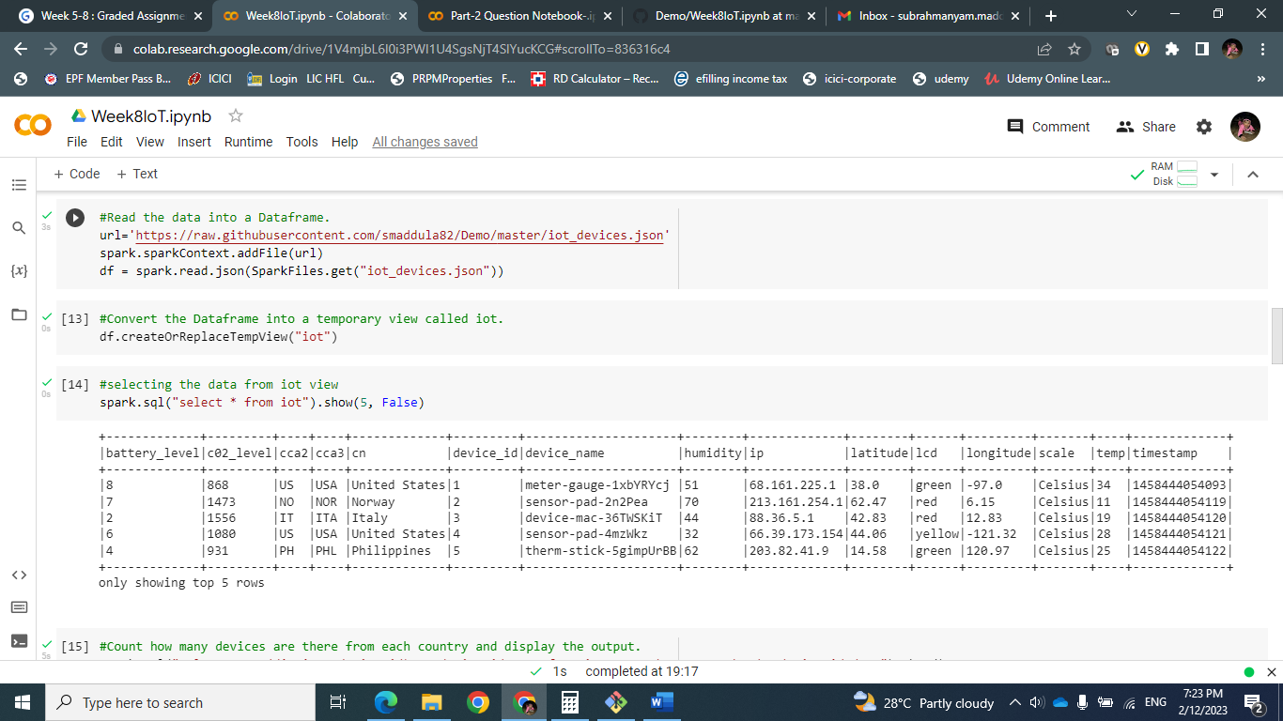
* Count how many devices are there from each country and display the output.
* spark.sql("select count(distinct device_id) as device_id,cca3 from iot group by cca3 order by device_id desc").show()
* 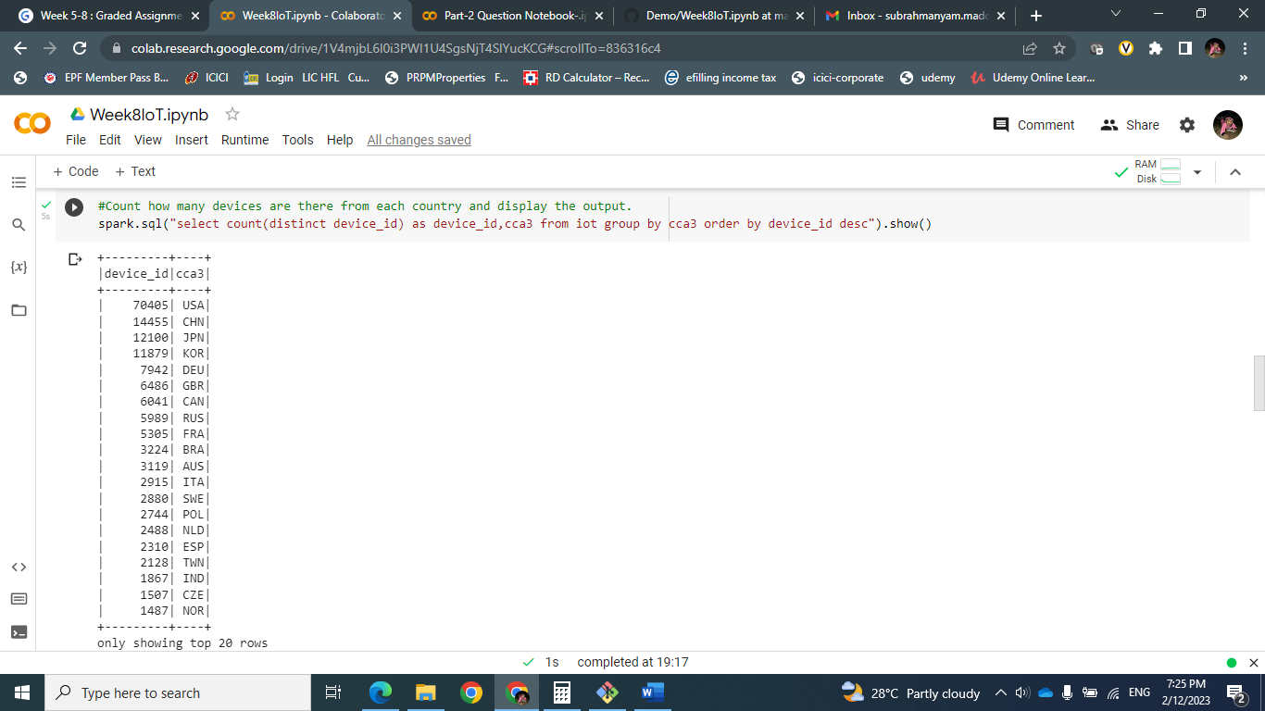
* Display all the countries whose carbon dioxide level is more than 1400. Sort the output in descending order.
* spark.sql("select cca3, c02_level from iot where c02_level > 1400 order by c02_level desc").show()
* 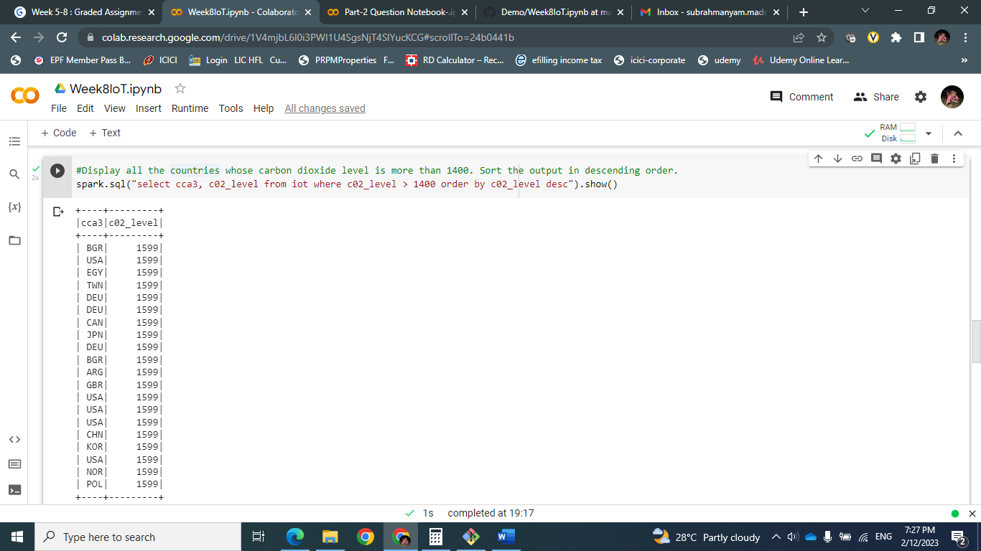
* Select all countries' devices with high-levels of C02 and group by cca3 and order by device_ids (Hint: For high CO2 level, the LCD status will be RED).
* spark.sql("select cca3, count(distinct device_id) as device_id from iot where lcd == 'red' group by cca3 order by device_id desc").show()
* 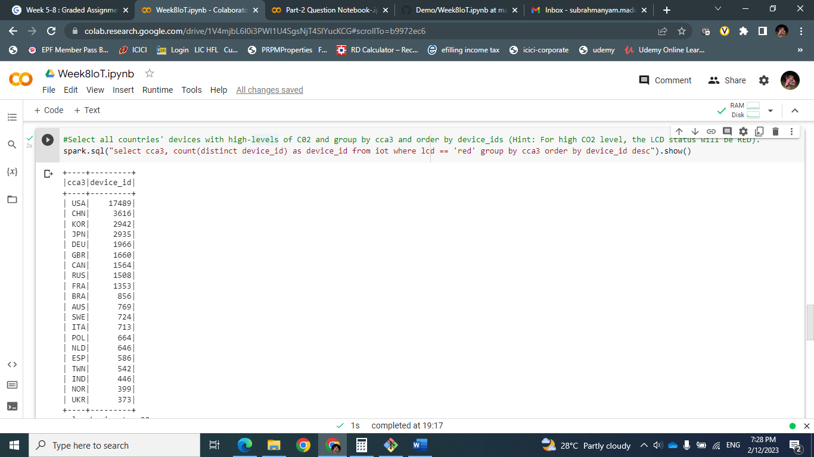
* find out all devices in countries whose batteries need replacements.
* spark.sql("select cca3, count(distinct device_id) as device_id from iot where battery_level == 0 group by cca3 order by device_id desc").show()
* 